Swift Extra Credit 2: iOS Development

**Files to Submit: tipCalculator.xcodeproj**

**Points: ___**

Now, we’ll use our newly development Swift skills to create a tip calculator app (very exciting I know, but you gotta start somewhere). Use the following tutorials to walk you through the process of using Xcode’s iOS development software.

<https://www.youtube.com/watch?v=E5vqU95EKIQ>

<https://www.youtube.com/watch?v=YVn83l6Uu30>

Notes:

* The first time you create a project will have to create and download a profile under the “Team” heading. Then your (Personal Team) appears in the dropdown menu.
* You need to Control-drag to get the blue line to create a link between objects and the code.
* If you change or delete a variable of an IB link you need to make sure you delete the old link and create a new one. Otherwise, you will get a ‘nsunknownkeyexception’ error. You can delete an IB connection by using the Connections Inspector (left) or by right-clicking on the object (right) and clicking the “x.”

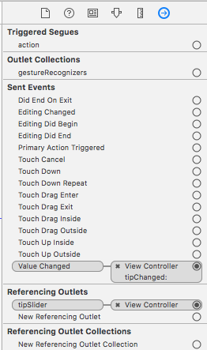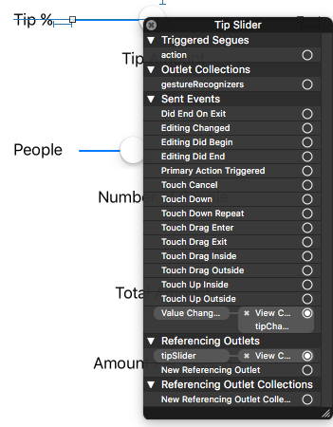

For more info on iOS development: <https://developer.apple.com/library/content/referencelibrary/GettingStarted/DevelopiOSAppsSwift/index.html#//apple_ref/doc/uid/TP40015214-CH2-SW1>